**Five Finger Breathing**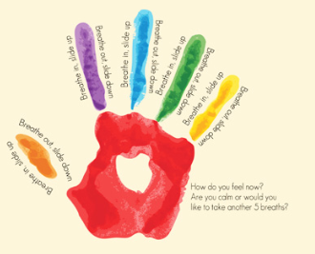

**Start at your thumb and trace around your fingers as you inhale and exhale.**

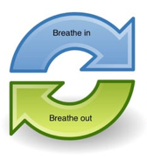

Mindfulness Strategy

Rainbow Search



Look around the room and try to find one thing that is red, orange, yellow, green, blue, and purple. Think about your favorite color and why you like it.